**VILJOENSKROON TRUCK STOP**

**Viljoenskroon Truck Stop** is a new truck stop situated in Viljoenskroon, Free State in the industrial area with easy accessibility. The truck stop is security fenced, with security lights at night and 24/7 on-site security. Clean restrooms is on a high standard. A braai area is available. Trucks can check their loads on a weighbridge which is situated on the premises.

**Services we render:**

* Safe parking for 30 trucks
* Open 24/7
* Security 24/7
* Clean restrooms
* Weighing of trucks
* Cash or card machine and accounts available

Overnight parking R 80 Weigh R 50

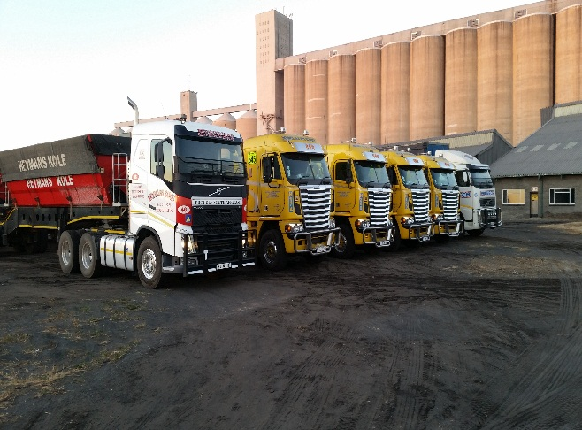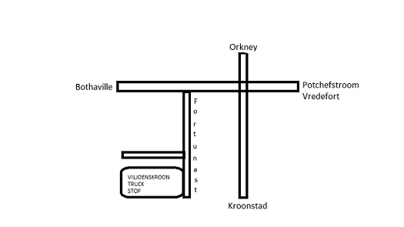

Contact detail: 083 409 5304 E Mail: [fgalore@mweb.co.za](mailto:fgalore@mweb.co.za)

Fortunastreet, VILJOENSKROON

-27.208838,26.926700

PARKING ON YOUR OWN RISK